Task-1A
Observe layout of data in memory using gdb
Define variables of different types initialized with predefined data. The variables should be local variables, global variables, static variables, constants. Put a break point in gdb on main function and observe the memory layout of the variables in memory. Understand stack and heap memory areas.
// observe layout of data in memory using gdb
#include <stdio.h>
#include <stdlib.h>

//defining constants
#define CONST_INT 500
#define CONST_FLOAT 600.5

//global variables
int global_variable = 100;
float global_float = 200.5;

//static variables
static int static_variable = 300;
static float static_float = 400.5;

int main() {
//local variables
int local_variable = 700;
float local_float = 800.5;

//defining constants
const int constant_variable = 900;
const float constant_float = 500.5;
const int a = CONST_INT;
const float b = CONST_FLOAT;

printf("Address of global_variable: %p\n", (void*)&global_variable);
printf("Address of global_float: %p\n", (void*)&global_float);
printf("Address of global static_variable: %p\n", (void*)&static_variable);
printf("Address of global static_float: %p\n", (void*)&static_float);
printf("Address of local_variable: %p\n", (void*)&local_variable);
printf("Address of local_float: %p\n", (void*)&local_float);
printf("Address of constant_var: %p\n", (void*)&constant_variable);
printf("Address of constant_float: %p\n", (void*)&constant_float);
printf("Address of Macro CONST_INT: %p\n", (void*)&a);
printf("Address of Macro CONST_FLOAT: %p\n", (void*)&b);
return 0;
}
Break point 1
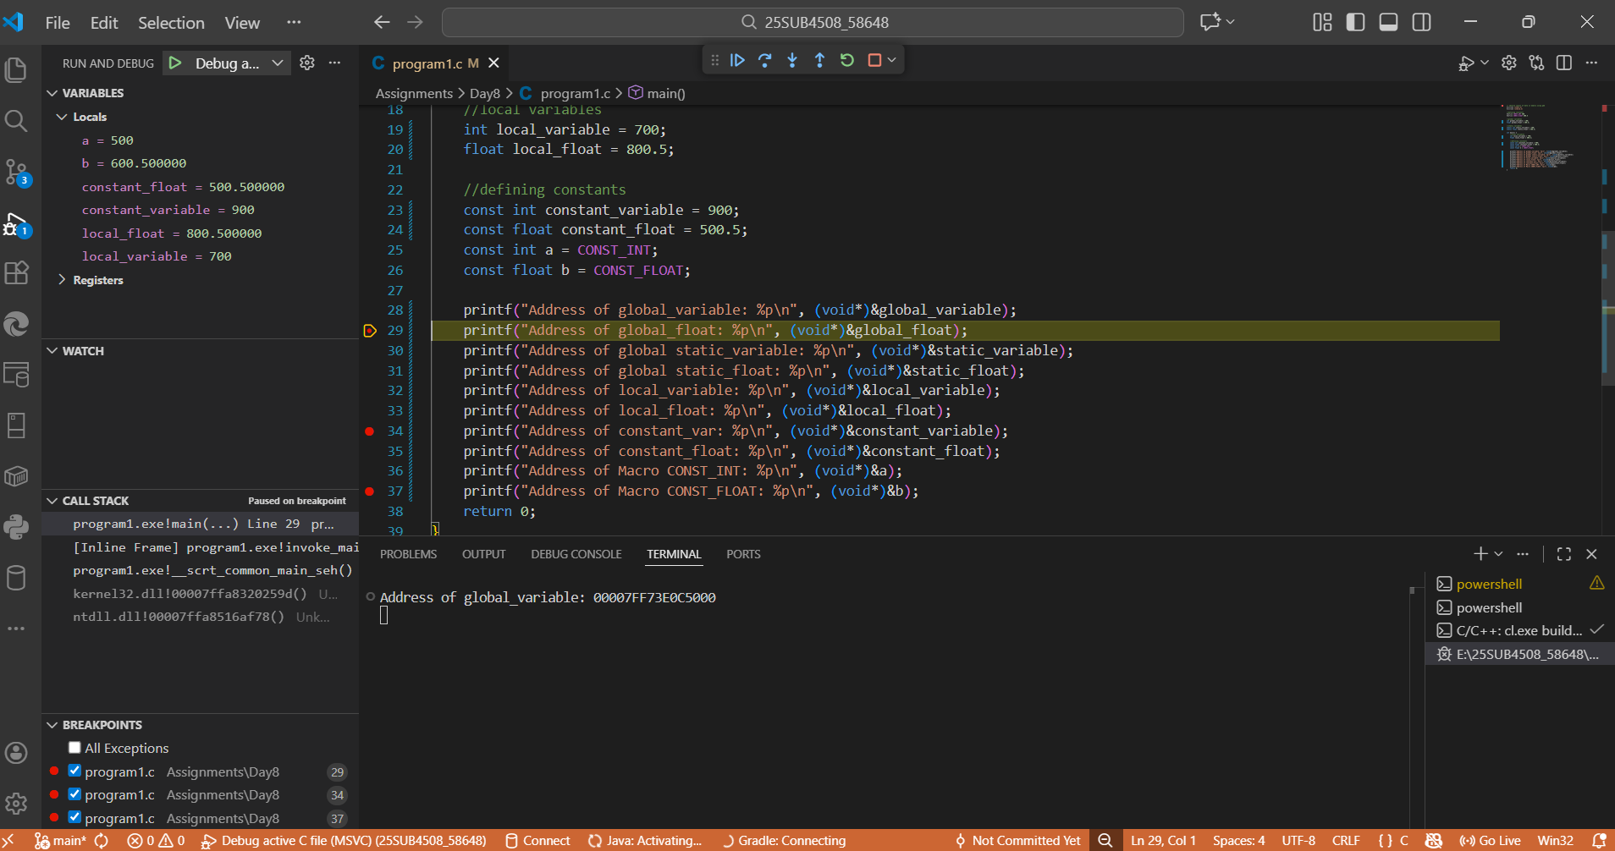
Call stack
Break point 3
Break point 2

Using gdb
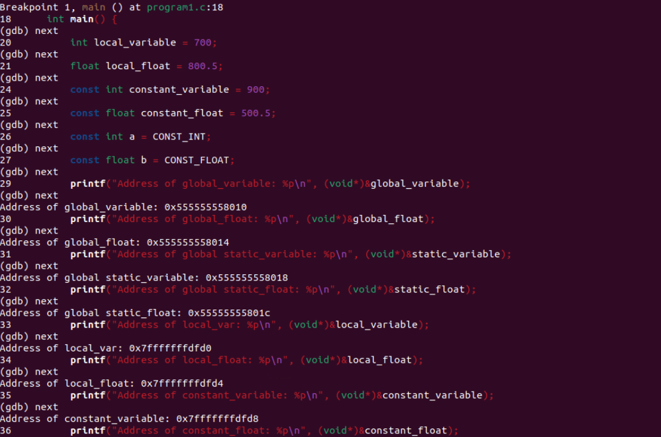
Call stack:
- call stack keep track of function calls and variable we use .call stack is a stack follows LIFO order to provide faster access.
- Data exist here until function execution feed freed here.
- Automatic Memory allocation
- Exception –StackOverFlow error

Heap Memory:
- Heap memory follows first in first out (FIFO).
- Manual memory allocation, we need to free it.
- Slower accesss due to dynamic allocation
- Execution – OutofMemoryError

